TechTP Turboprop first run celebration and demonstration: first Clean Sky 2 demonstrator successfully tested

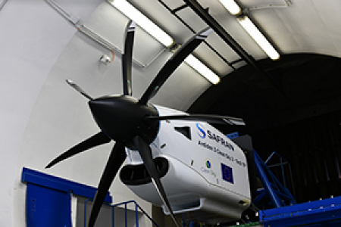

21 October 2019

The recent first run of the TechTP Turboprop engine demonstrator, an important milestone for Clean Sky 2, was celebrated at an event on 17 October at Safran Helicopters’ facilities in Tarnos (France) with the participation of Safran Helicopter Engines, Clean Sky, and the partners of the projects (from Clean Sky 2’s Calls for Proposals) which are contributing to this demonstrator. During the event, a test bench visit and real time TechTP engine running demonstration was performed by the Safran Helicopter Engines team, and the partners had the opportunity to present the outcomes of their projects and their contributions.

The first ground test of the Turboprop engine demonstrator took place on 12 June 2019, paving the way to a new generation of turboprop engines for business and short range regional application with the aim to offer a double digit fuel emission reduction compared to the existing generation of engines. The demonstrator aims to reach TRL5+ by the end of 2021.

This engine demonstrator is part of Clean Sky 2’s ENGINE ITD activities and is led by Safran Helicopter Engines, involving more than 20 partners (including SMEs and academia) across 8 different European countries with a total budget of around €40 million, with €20 million of EU funding.

The development of the ground demonstration of the integrated turboprop power plant system, including propeller, air intake & nacelle, is covering the following aspects:

* Improvement of core engine technologies
* Development of turboprop key enabling technologies
* Study & assessment of integration issues